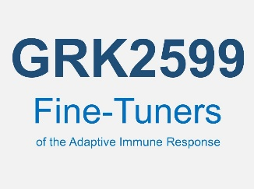

Friedrich-Alexander University

Erlangen-Nürnberg

Faculties of Medicine and Natural Sciences



**Research Training Group 2599 (RTG2599)**

„FAIR – Fine-Tuners of the Adaptive Immune Response”

The newly established Research Training Group GRK2599, funded by the German Research Foundation (DFG), announces the opening of:

*11 Doctoral Positions (Dr. rer. nat.)*

*(January 01, 2024 for 3 years)*

The goal of the proposed Research Training Group (RTG) 2599 is to establish an internationally competitive research and training program to promote young scientists and medical students in the field of immunology. The research field focuses on defined molecular regulators in different cells of the immune system, including DCs and macrophages and subpopulations found within the group of T cells and B cells and their roles in inflammation, autoimmunity, infection and cancer.

To identify and explore new fine-tuners of adaptive immune responses and immune memory. The doctoral candidates will apply genome-wide transcriptome analysis, modern imaging techniques, transgenic mouse technologies and CRISPR-mediated genome editing.

Core elements of the training program are a bi-weekly RTG Paul-Ehrlich-Club, research-specific as well as interdisciplinary hard-skill and soft-skill workshops, internal RTG research retreats and RTG network meetings, the RTG guest speaker series, the RTG’s public relation program as well as a trainee program financed by the RTG in research labs outside of Germany.

We are looking for natural science doctoral candidates from Germany and abroad with a very good master’s degree in biology, biochemistry, immunology, pharmacy, human biology, chemistry, or related subjects.

Detailed information about the research and training programs and the application process can be found on our homepage at http://www.lymphozyten.de.

The ONLINE application starts now and will be closed after June 30, 2023.